# PRJ7: Web Application Design Brief

## Jason A. W. MacDonald

### Nelson Marlborough Institute of Technology

Contents

1. Executive Summary 3

2. Introduction 4

3. User Requirements 5

3.1. General Functionality 5

3.2. Section Specific Functionality 5

3.2.1. Account Management 5

3.2.2. Adventure Gallery 5

3.2.3. Adventure Library 5

3.2.4. Adventures 5

3.2.5. Events 5

3.2.6. Links 5

3.2.7. Adventure Play 5

3.3. User Requirement Summary 6

4. Site Goals 6

4.1. Purpose 6

4.2. Short Term Goals 6

4.3. Long Term Goals 6

4.4. Site Goals Summary 6

5. User Experience 6

5.1. Audience Definition 6

5.1.1. Content Creators 6

5.1.2. Adventurers 6

5.2. Scenarios 7

5.3. Competitive Analysis 9

5.3.1. Chooseyourstory.com 9

5.3.2. Squiffy and Quest 10

5.3.3. Twine 11

5.4. Competitive Analysis Summary 11

6. Site Content 12

6.1. Content Grouping and Labelling 12

6.1.1. Adventures 12

6.1.2. Projects 12

6.1.3. Account 12

7. Functional Requirements 12

7.1. Frontend 12

7.2. Backend 12

7.3. Database 12

7.4. Other 12

7.5. Functional Requirement Summary 12

8. Site Structure 13

8.1. Site Structure Listing 13

8.2. Architectural Blueprints 13

9. Visual Design 15

9.1. Wireframes 15

9.1.1. Main Layout 15

9.1.2. Adventures 16

9.1.3. My Library 17

9.1.4. My Projects 18

9.1.5. Project 19

9.1.6. Chapter 20

9.1.7. Links 21

9.1.8. Adventure 22

9.1.9. Login / Register 23

9.1.10. Account 24

9.2. Mock-ups 25

10. Updates 26

Back buttons 26

# Executive Summary

This report is the documentation for the **Analysis** and **Design** phase for a proposed **web**-**application.**

The purpose of this report is to reveal and establish **requirements**, **goals** and **content** for the project and moves into the initial **design** of the **user** **interface**.

Blazor is the chosen technology for the front-end user interface. The ASP.NET Blazor feature uses a **component**-**based** **architecture** which allows creation of high-level components that can replicate the same functionality in multiple places.

For example, the list functionality required by the store, user library and projects section can use the same adventure list component. The project can also create a generic list component that can provide the base functionality for different lists. For example, a generic list can be used by and adventure list, or chapter list, and those lists can be used by multiple components.

The purpose of the application is to provide an online user-created content platform for Pen and Paper style adventures for children, beginners or those interested in a more casual tabletop gaming experience. It provides a platform for both creation and play of tabletop adventures, where resources such as character sheets and equipment sheets can be uploaded and printed.

The functional requirements revealed are relatively standard for a web application. The design phase of the SDLC would normally define each system in more detail. As Blazor is an unknown technology, the design of these systems will be revealed during the implementation (research) phase. The Design phase will focus on the user interface as a result.

An additional outcome of the analysis phase has revealed a supplementary focus for the project which will attempt to minimize the learning curve of its users by displaying the right help and information at the right time. This may be through tool tip style help or hidden information panels that can be displayed when needed.

# Introduction

The purpose of the application is to provide an online user-created content platform for Pen and Paper style adventures for children, beginners or those interested in a more casual tabletop gaming experience.

Current options for tabletop gaming often involve large rulebooks, mathematical evaluations and a steep learning curve which may be daunting to newcomers and outside the reach of younger adventurers.

Similar gaming genres such as Collectable Card Games like Magic the Gathering, and even the children targeted Pokémon, have expanded and become more difficult to understand. It can be tough trying to keep up with the evolution and mechanical change.

The proposed application will make use of a small sub-set of table-top gaming rules and concepts which will allow users to generate simple pick a path style adventures online, or use adventures created by others.

Players will be able to print off required resources to supplement the game such as character sheets with an area for recording basic stats (health, attack, defense and brains). The users will also be able to print off equipment and item pages which can be cut out, coloured and attached to the user’s character sheet.

Content creators will be able to generate adventures by forming and connecting a range of events, including:

* **Story Event:** *An event which progresses the narrative of the story.*
* **Decision Event:** *An event where players will make decisions, the outcome will be determined by the event details designed by the content creator.*
* **Stat Check Event:** *Players are required to roll dice and make small calculations to see if they succeed or fail at a provided task and are presented with an outcome.*
* **Battle Event:** *Enemies will have a range of stats, and an attribute. Players are able to fight an enemy by rolling dice, adding their personal value to the attribute of the opponent and see if their value is higher than the enemy’s.*
* **Additional Event:** *Future development.*

Players will be able to interact with an adventure via computer or mobile device. The players will see a description of the event and choices they can make or actions they can perform. Once players resolve the requirements of the event, they can select an outcome, respond to the outcome, and move on to the next event.

# User Requirements

## General Functionality

* The application will need to be available both on **desktop** and **mobile** devices.
* The application will cater primarily for one type of user which will be able to use both **content** **creation** and **adventure** mechanics of the application.

## Section Specific Functionality

Users will need to be able to:

### Account Management

* Register a new account,
* Login to an existing account, and
* Edit account details.

### Adventure Gallery

* View a gallery of available adventures,
* Add adventures to their library,
* Play adventures directly from the gallery.

### Adventure Library

* Remove adventures from their library,
* Play adventures directly from their library.

### Adventures

* Create a new adventure,
* View a gallery of their created adventures,
* Edit an existing adventure,
* Add an image to an Adventure,
* Add resource images to an adventure, and
* Delete an adventure.

### Events

* Create a new event,
* View a list of events,
* Edit an existing event,
* Add an image to an event, and
* Delete and event.

### Links

* Create a new link,
* View a list of links,
* Edit an event, and
* Delete an event.

### Adventure Play

* Download and print any resources,
* View and navigate through events, and
* Save current position in an adventure.

## User Requirement Summary

Several of the sections require similar functionality. ASP.NET’s Blazor feature uses a **component**-**based** **architecture** which allows creation of high-level components that can replicate the same functionality in multiple sections.

# Site Goals

## Purpose

The purpose of the application is to provide an online platform for users to create and play tabletop adventures.

## Short Term Goals

* Provide an online content platform for basic pen and paper style adventures for children, beginners or those interested in a more casual tabletop gaming experience.
* Provide an introduction to table-top gaming.

## Long Term Goals

* Provide an online content platform for pen and paper style adventures with a range of adventurer levels and difficulties.
* Provide an online community environment.

## Site Goals Summary

The scope of the application for the PRJ course is limited to the short-term goals with a deliverable providing proof of concept for the use of Blazor in web development.

# User Experience

## Audience Definition

Although users will be able to function as both content creators and adventurers, each role can be targeted differently in terms of design and usability.

### Content Creators

Content Creators will be able to navigate through the project section of the application, creating, editing and releasing adventures to the store. Content creators are expected to be at the higher end of the age group between 12 and 18 years old.

### Adventurers

Adventurers will come from a range of demographics. The adventures will initially target younger children between 8 to 15 years old. It is expected that many adventurers will be introduced to the platform through parents or siblings.

## Scenarios

***John Smith is and avid player among the Dungeons and Dragons Role Playing community. His children Jane and Joe often watch John playing through adventures with his friends and want to play but at ages 6 and 8, the mechanics of the game are too complicated.***

***John heard about the platform through a friend and wants to try it out with the kids. He grabs his mobile phone and searches for an adventure. The adventure he chooses requires a few resources:***

* ***Some printed character and resource sheets,***
* ***Coloring in equipment,***
* ***Scissors,***
* ***Glue.***

***John collects the items required and gathers the young adventurers. As they sit down to play, John starts the adventure on the application, reading out the narrative. John then clicks the button to the next event, which explains how to set up for the adventure (Naming characters, sorting stats etc).***

***The team then set off into the unknown.***

***Because this is the first time using the application, John has to look up the help system to make sure he is completing stat checks and decision events correctly.***

***Around an hour later, the kids are getting a little restless and John decides they will have a break for a while and head out for a bike ride, and they can pick up later where they left off.***

Notes:

* The adventures displayed in the store and user libraries should provide a description of the adventure with a list and links to the required resources. This could be displayed directly on the card or within a new ‘page’.
* A help section should be provided for each event to provide contextual help. This could be hidden until a button is clicked.
* Adventure progress should be recorded so users can leave and come back to the same point of their adventure.

This functionality will require the user to be logged in. As John started an adventure directly from the store page, a notification requesting John to login should be provided, and the adventure added to his library. If John does not have an account or doesn’t want to login, the application should prompt John to create an account to save progress or skip to continue without the ability to save progress.

***16-year-old Jane Doe has decided to create an adventure to share with her friends. She has played around with the application before so has an account and is familiar with the layout. She starts a new project and enters the details.***

***Jane then creates the first chapter, entering the title, description and uploading an image. But Jane isn’t happy with the image and changes it before deciding that she doesn’t want an image on the first chapter and removes it.***

***With the narrative finished for the first chapter, Jane creates a new link which will take the user to chapter two. Unfortunately, Jane hasn’t created chapter two, so she is unable to select it from the list of chapters to connect the link to.***

***Jane is able to create and connect the link to a new chapter directly from the links page.***

Notes:

* The image functionality should include uploading, changing and deleting images.
* A list of chapters should be included in the links section where the user can select a chapter as the target for a link.
* If the user hasn’t created the chapter that a link will be connected to, they should be provided the option to create and link to a new chapter directly from the links page. This stops the user from having to navigate out to the main project to create a new chapter and navigating back to the chapter links to connect later.

## Competitive Analysis

Competition for the RPG or Interactive Story space comes from a range of angles. This analysis will focus on the digital angle which includes both websites and applications.

### Chooseyourstory.com

Chooseyourstory.com is an online interactive fiction website which allows users to create and play single player adventures online.

The site design is a little dated, lacks responsiveness and does not respond to changes in screen size. The project requires:

* A desktop experience for content creation, and
* A desktop or mobile experience for adventuring.

The site provides a wide range of help and resources through a list of links. This is bulky and may take time to find required information. Contextual help could filter information for the user and reduce the initial learning curve. Contextual help could be applied for both content creation and adventuring.

The website includes a community forum for users to share ideas and request or provide help. The community aspect is outside the scope of the current project but should be evaluated for future work.

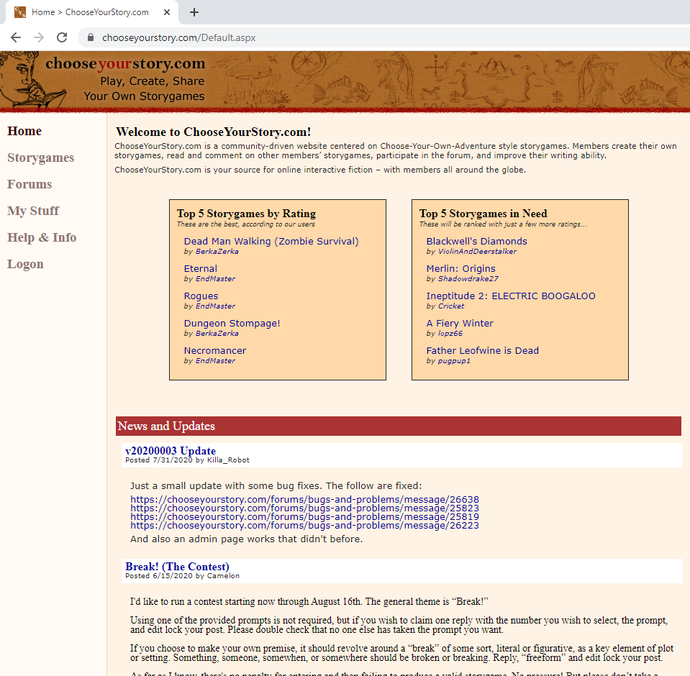 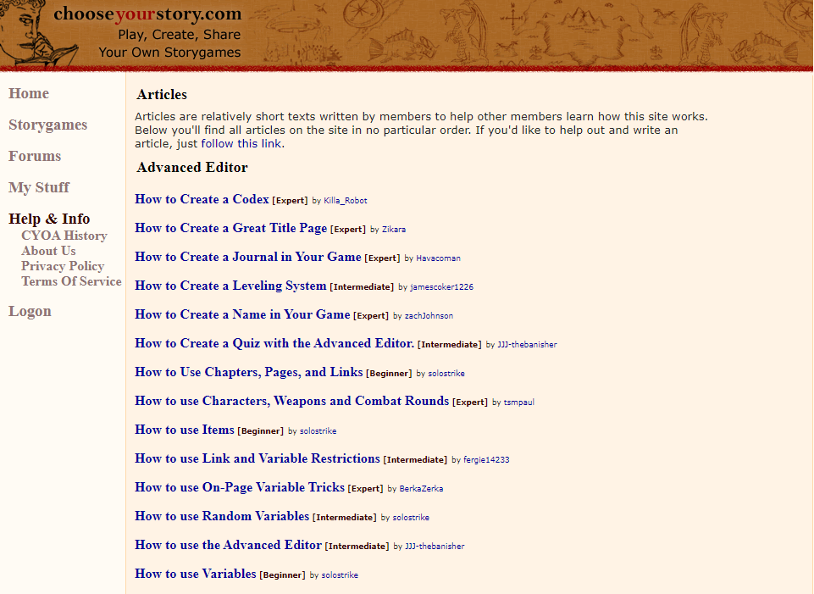

Sourced from: <https://chooseyourstory.com/Forums/Search.aspx>

### Squiffy and Quest

Squiffy and Quest are applications designed to allow users to create and play choose-your-own style adventures. Squiffy is a very lightweight editor and Quest is a more comprehensive application which allows navigation, interaction and inventory systems.

Squiffy is essentially a custom markdown editor which has a small learning curve but is also very limited. This can be a good option for a small interactive story but would become difficult to manage at a larger scale.

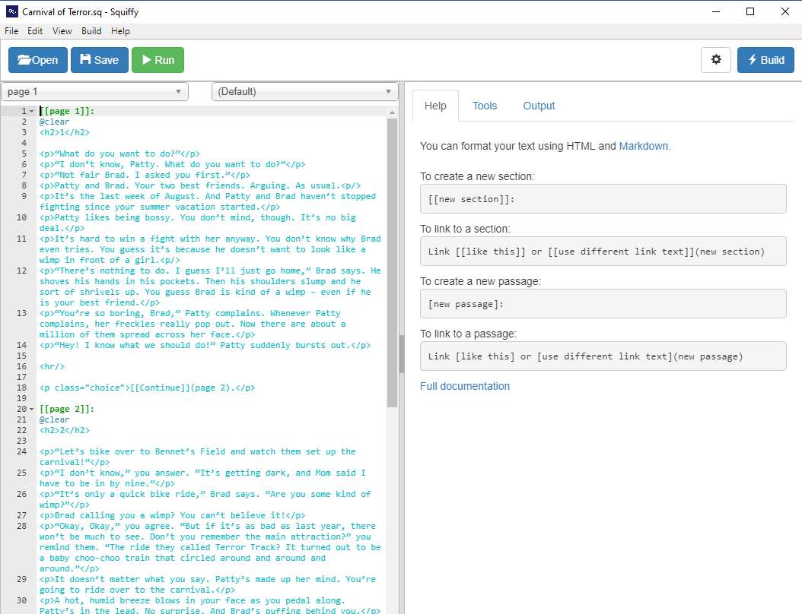

Quest has a far greater learning curve but provides the ability to create comprehensive text adventure games as well as interactive stories.

### Twine

Twine is an interactive story generator with a visual drag and drop system and Markdown editor. Twine is very simple to use, and its visual system makes it ideal to create and manage non-linear stories with many branches.

A visual representation is outside the scope of the current project but should be evaluated for future work.

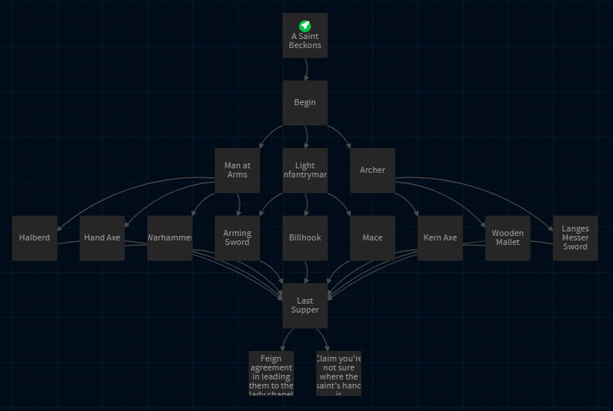 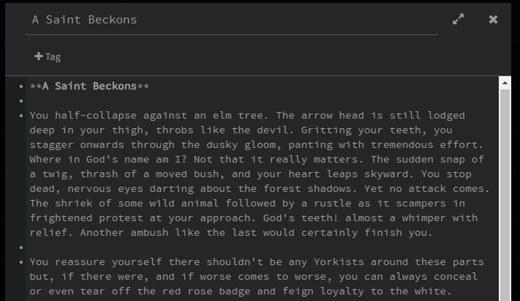

## Competitive Analysis Summary

There are many websites and applications that provide functionality which would benefit the project, such as:

* Community Environments,
* Visual Structure Management Tools,
* Custom Markdown Editors, and
* Range of help and tutorials.

Most aspects are outside the scope of this project but should be considered for future work.

The competitive analysis revealed there is a range of learning curves for each system. The project will focus on minimising this curve by providing contextual help when and where it might be required. Examples include pop up and hover information and expandable help details for both creating and playing through adventures.

# Site Content

## Content Grouping and Labelling

The initial application will contain three main content groups, adventures, projects and accounts.

### Adventures

* **Adventures:** A gallery of complete adventures that have been released.
* **My** **Library:** A gallery of adventures a user has added to their library.

### Projects

* **My** **Projects:** A gallery of released and unreleased adventures created by the user.

### Account

* **Account Information:** Basic account information for the user.

# Functional Requirements

### Frontend

* Reactive frontend interface,
* Form validation,
* Markdown compilation,
* Image browsing and uploading, and
* Pagination.

### Backend

* Communication with client, and
* Communication with database.

### Database

* Account details,
* User library details,
* Store details, and
* Adventure details.
  + Events
  + Links
  + Images

### Other

* Image storage.

### Functional Requirement Summary

The functional requirements revealed are relatively standard for a web application. The design phase of the SDLC would normally define each system in more detail. As Blazor is an unknown technology, the design of these systems will be revealed during the implementation (research) phase.

# Site Structure

## Site Structure Listing

* Home
  + Adventures
    - Adventure (Play)
  + My Library
    - Adventure (Play)
  + My Projects
    - Create / Edit Project
      * Create / Edit Chapter
        + Create / Edit Link
  + Login / Register
    - Account

## Architectural Blueprints

The diagram below illustrates a high-level view of the applications architecture. The application uses a very flat architecture with exception of the Project section. Content creation is separated into cascading sections which allows creators to focus on one aspect at a time and enables implementation of contextual help at each level.

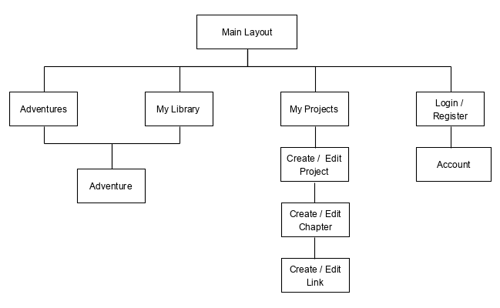

The following diagram also includes the components that will be required for each ‘*page’.* This reveals several components which could be reused throughout the application, including:

* Filters,
* Galleries,
* Pagination, and
* Generic Lists.

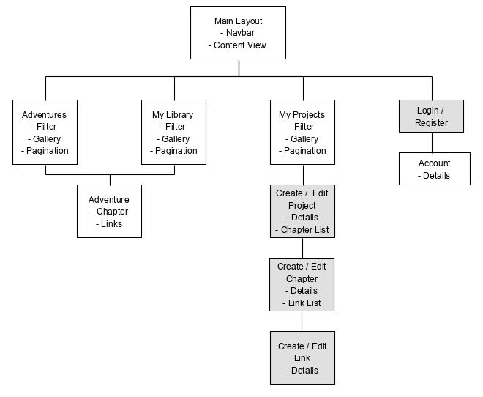

*The grey background indicates the component uses a form.*

# Visual Design

## Wireframes

### Main Layout

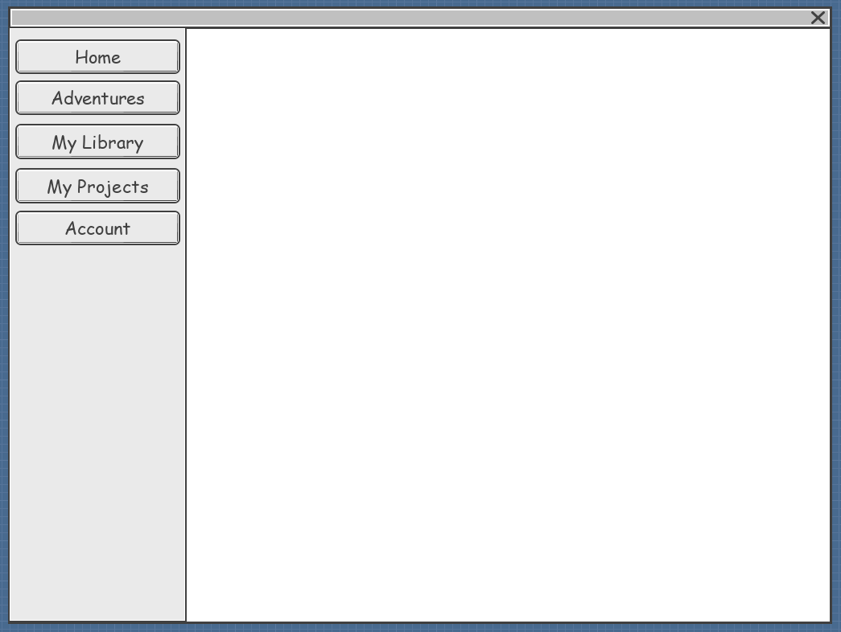

### Adventures

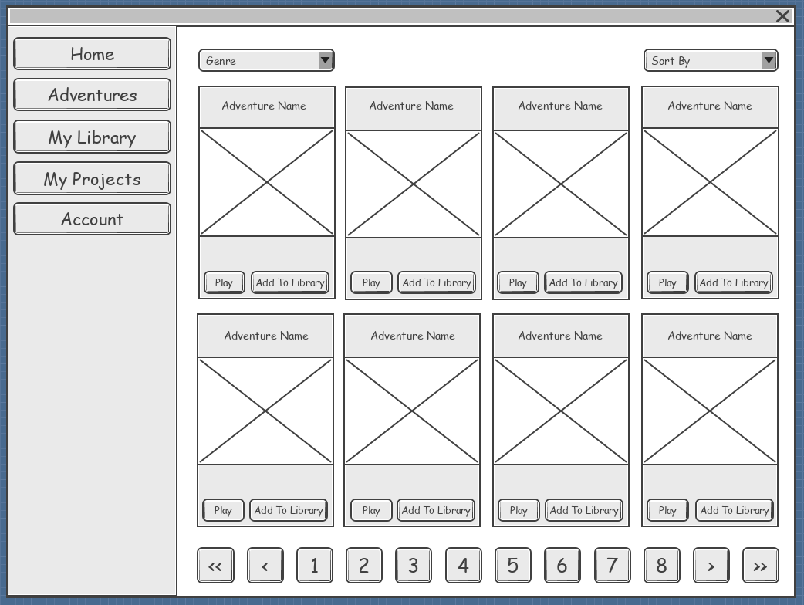

|  |  |
| --- | --- |
| Genre | Examples: Sci-Fi, Fantasy |
| Sort By | Examples: Latest, Oldest |
| Play | IF user is logged in THEN  IF adventure is in library THEN  GOTO ADVENTURE  ELSE  add adventure to library  GOTO ADVENTURE  ENDIF  ELSE  prompt user to login  IF user skips login THEN  GOTO ADVENTURE (No saving)  ENDIF  ENDIF |
| Add To Library | IF user is logged in THEN  IF adventure is in library THEN  tell user adventure is in library  ELSE  add adventure to library  ELSE  prompt user to login  ENDIF |

### My Library

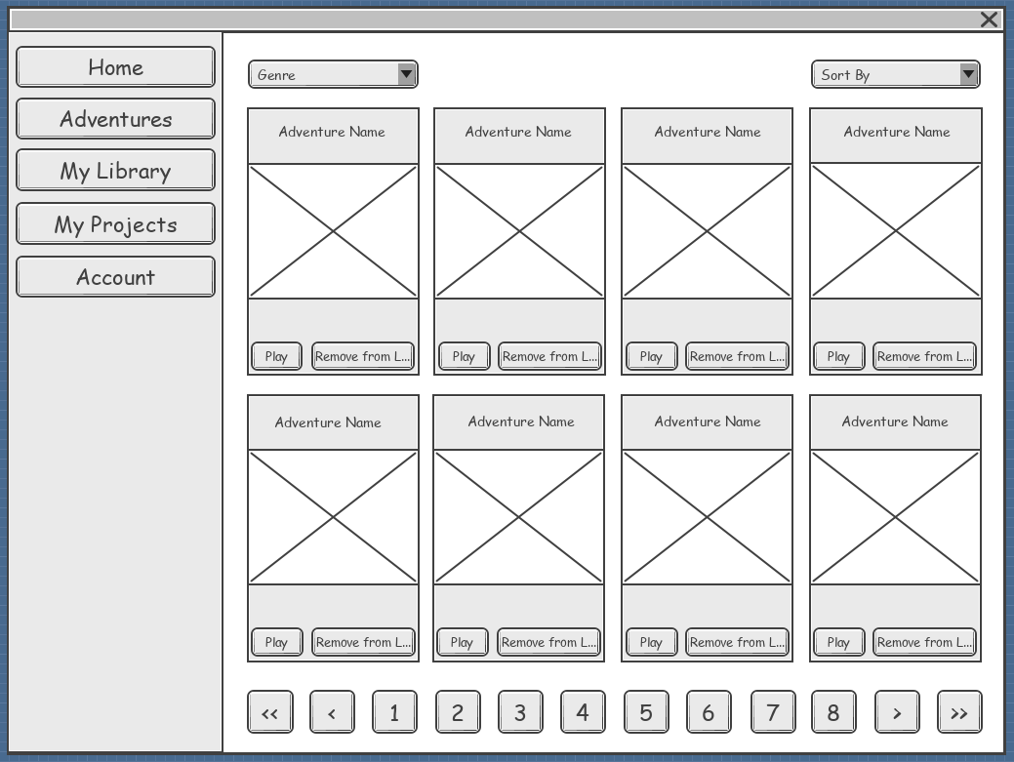

|  |  |
| --- | --- |
| Genre | Examples: Sci-Fi, Fantasy |
| Sort By | Examples: Latest, Oldest |
| Play | GOTO ADVENTURE |
| Remove from Library | prompt user to confirm removing adventure from library  IF confirmed THEN  Remove adventure form library  ENDIF |

### My Projects

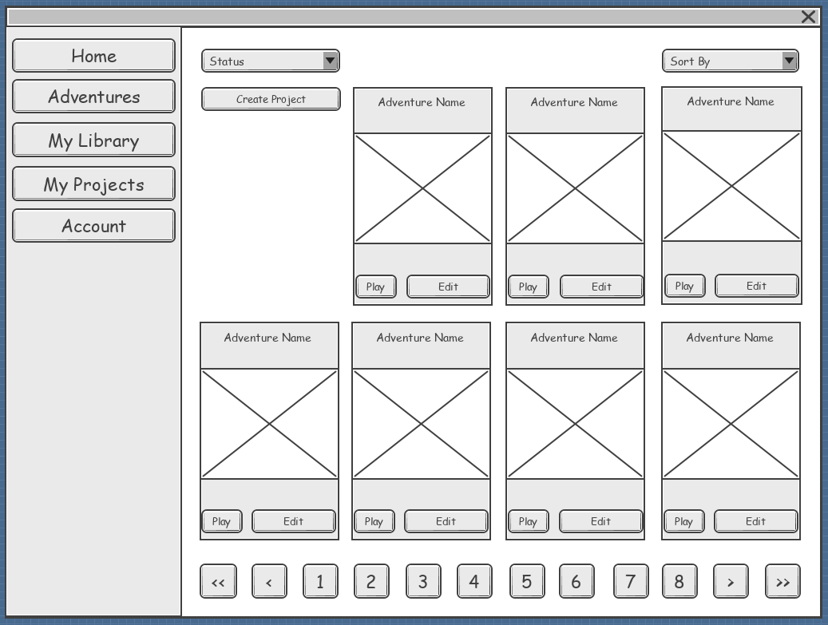

|  |  |
| --- | --- |
| Status | Examples: all, released, unreleased |
| Sort By | Examples: Latest, Oldest |
| Create Project | GOTO PROJECT |
| Play | GOTO ADVENTURE |
| Edit | GOTO PROJECT |
| Remove from Library | (delete button not shown in wireframe)  prompt user to confirm removing adventure from library  IF confirmed THEN  Remove adventure form library  ENDIF |

### Project

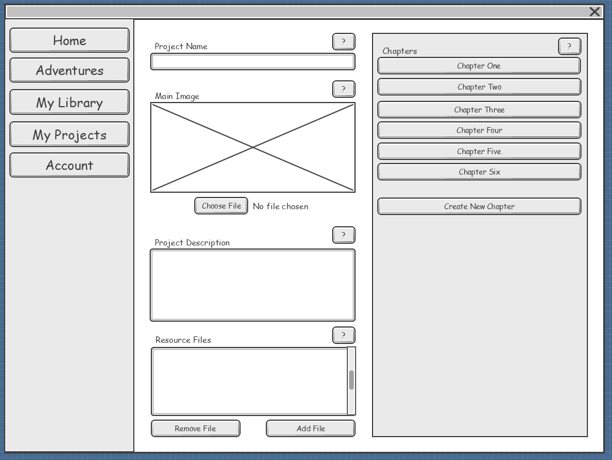

|  |  |  |  |  |
| --- | --- | --- | --- | --- |
| Data | Type | Validation | Example | Notes |
| Project Name  (Title) | String | 3 – 100 char | ‘The Cloud Dungeon’ |  |
| Main Image  (Image) | String | TBD | /somewhere/img01 | Address for the stored image.  Further research required. |
| Project Description  (Description) | String | TBD | [see below*] | Requires markdown.  Further research required. |
| Resource Files  (ResourceList) | String | TBD | /somewhere/res01 | List of addresses for the stored images.  Further research required. |

*

**Into the Clouds**

You and your fellow greedy friends are about to set out on an adventure in a cloud dungeon. The long-dead queen of the cloud kingdom, Tyrannie, store all of her wealth and riches in the cloud dungeon.

She devised chemical process for thickening and stabilizing the clouds leading to the ability to build a country in the sky.

That country is now called the yonder, and you’re headed there to seek your fortune. Good for you.

|  |  |
| --- | --- |
| Choose File (Main Image) | open file explorer for file upload |
| Chapter (*n*) | GOTO CHAPTER |
| Create New Chapter | GOTO CHAPTER |
| Remove File | IF file is selected THEN  prompt user to confirm removing file from resource list  IF confirmed THEN  remove file from resources list  ENDIF  ELSE  tell user no file selected  ENDIF |
| Add File | open file explorer for file upload |
| ? | display contextual help |

### Chapter

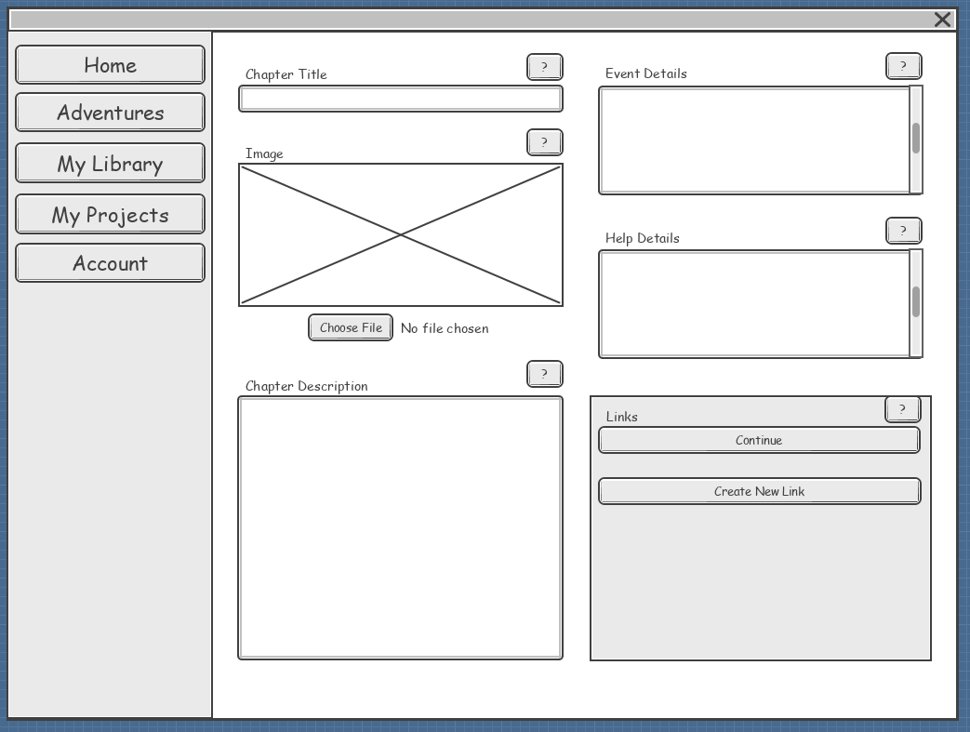

|  |  |  |  |  |
| --- | --- | --- | --- | --- |
| Data | Type | Validation | Example | Notes |
| Chapter Title  (Title) | String | 3 – 30 char | ‘Cloud Nine’ |  |
| Image  (Image) | String | TBD | /somewhere/img01 | Address for the stored image.  Further research required. |
| Chapter Description  (Description) | String | TBD | [see below*] | Requires markdown.  Further research required. |
| Event Details  (EventDetails) | String | TBD | [see below**] | Further research required. |
| Help Details  (HelpDetails) | String | TBD | [see below***] | Further research required. |

*

The evil queen built the cloud dungeon primarily as a revenue-generating operation.

Basically, the cloud dungeon was a massive, massive, tourist trap.

The town that grew around the dungeon was named, optimistically, Cloud 9. Sadly, as the Cloud 9 dungeon lost hordes of tourists to a new line of fancy digital dungeons, Cloud 9 was ruined, leaving the townspeople poor.

It’s a cheerful place.

**

When you select and pay for a weapon, add to your stats, writing the new total in the next open box. You may carry as many weapons as you want, but you must find a way to glue / tape them to your character sheet.

***

If you can’t agree on a team decision, assign a number to each choice and roll a die to determine the course of action. Or just compromise.

|  |  |
| --- | --- |
| Choose File (Main Image) | open file explorer for file upload |
| [Links] (*n*) | GOTO CHAPTER |
| Create New Link | GOTO LINK |
| ? | display contextual help |

### Links

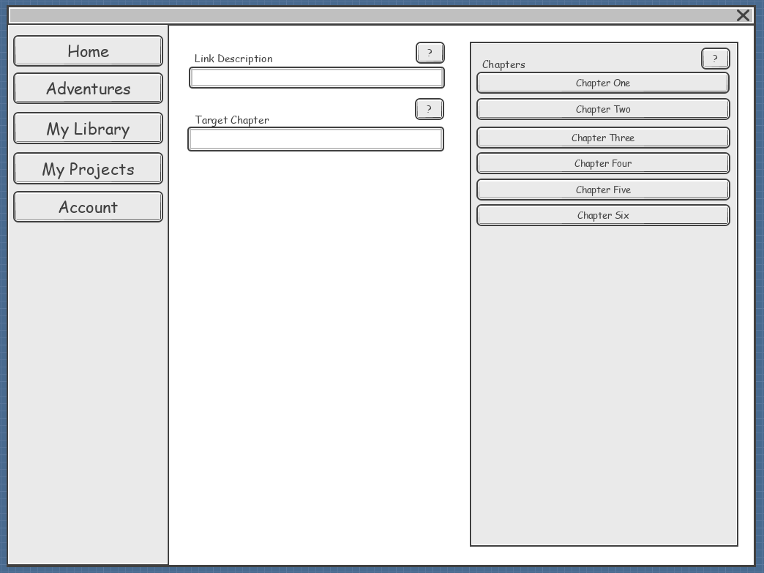

|  |  |  |  |  |
| --- | --- | --- | --- | --- |
| Data | Type | Validation | Example | Notes |
| Link Description  (Description) | String | 2 – 50 char | ‘Continue’ | Text displayed on the link button. |
| Target Chapter  (Target) | int | Automatically assigned. | 3 | Uses the primary key of a chapter. |

|  |  |
| --- | --- |
| Chapter (*n*) | add chapter primary key to links target chapter |
| ? | display contextual help |

### Adventure

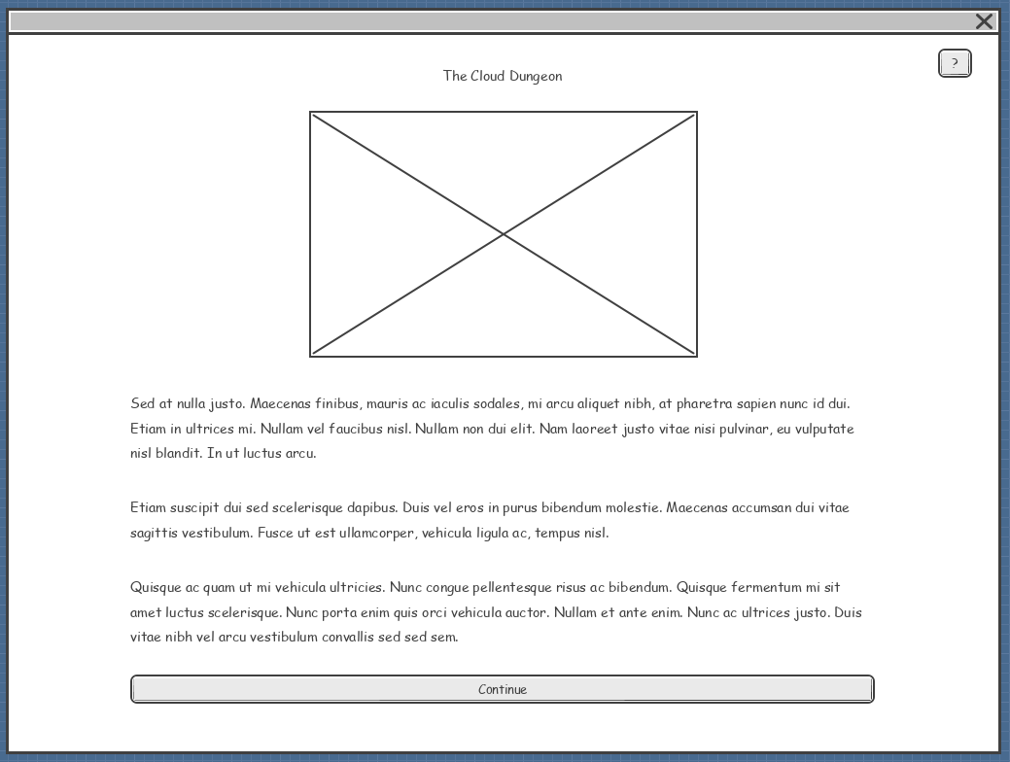

|  |  |
| --- | --- |
| [Link] (*n*) | navigate to chapter |
| ? | display contextual help |

### Login / Register

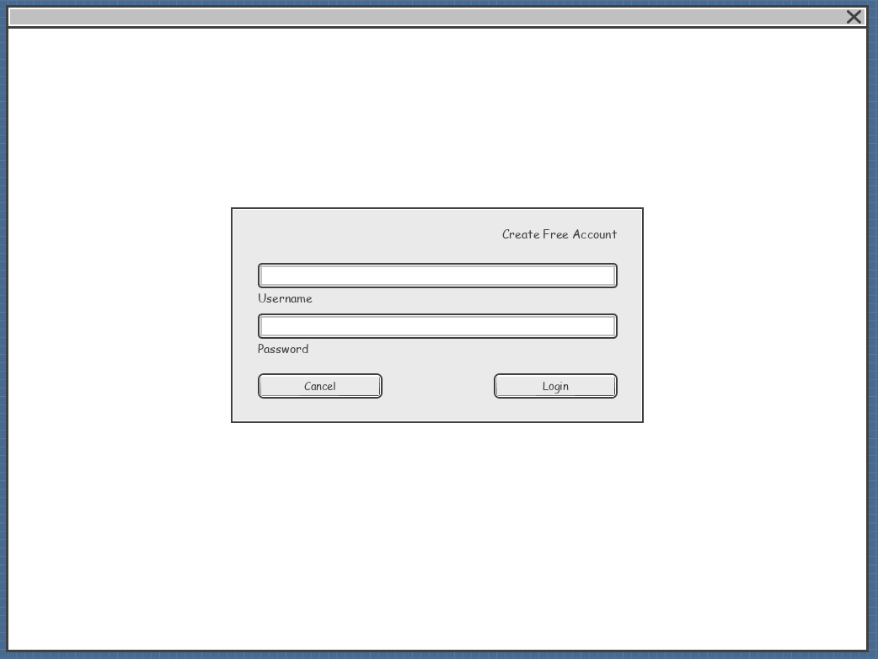

|  |  |  |  |  |
| --- | --- | --- | --- | --- |
| Data | Type | Validation | Example | Notes |
| Username  (email) | String | 2 – 100 char  Email format | someone@email.com | Future work could allow a username or email to be used. |
| Password | String | 8 – 100 char | Th!s!s@T3rr1BleP@ssw0rd |  |

|  |  |
| --- | --- |
| Create Free Account | change to register functionality (or login functionality) |
| Cancel | close modal |
| Login / Register | login |

### Account

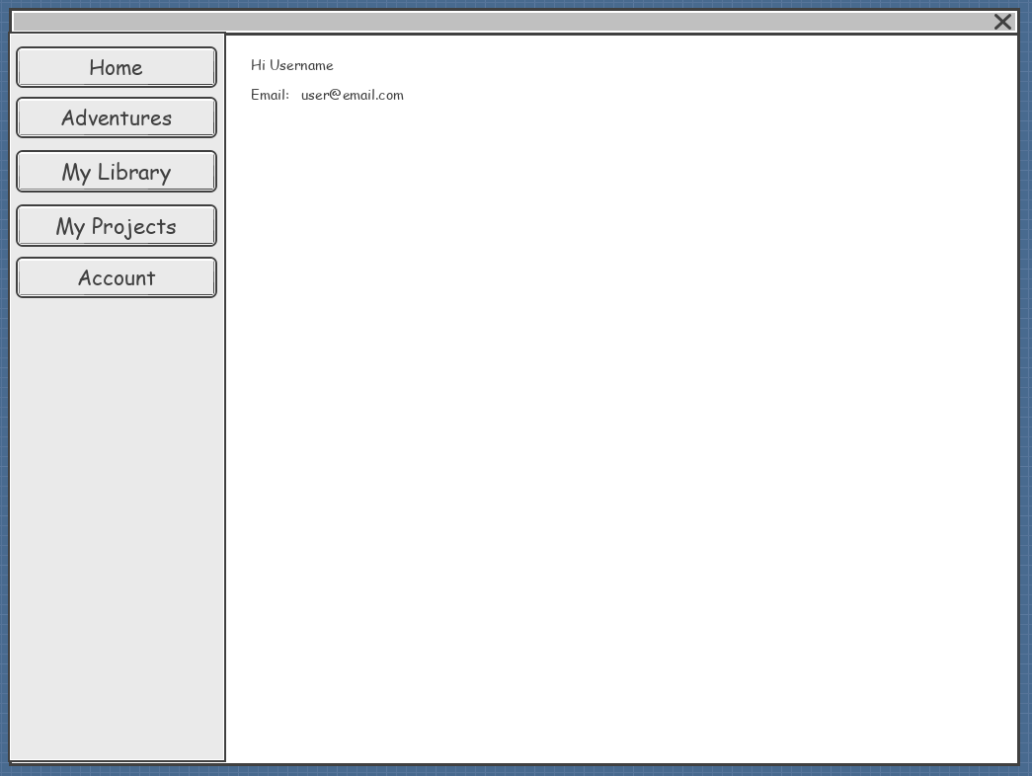

## Mock-ups

# Updates

### Back buttons

Navigation buttons to go back need to be implemented in several areas. This will require a cancel option and a save and close option.

### ERD Entity Relationship Diagram (needs updating)

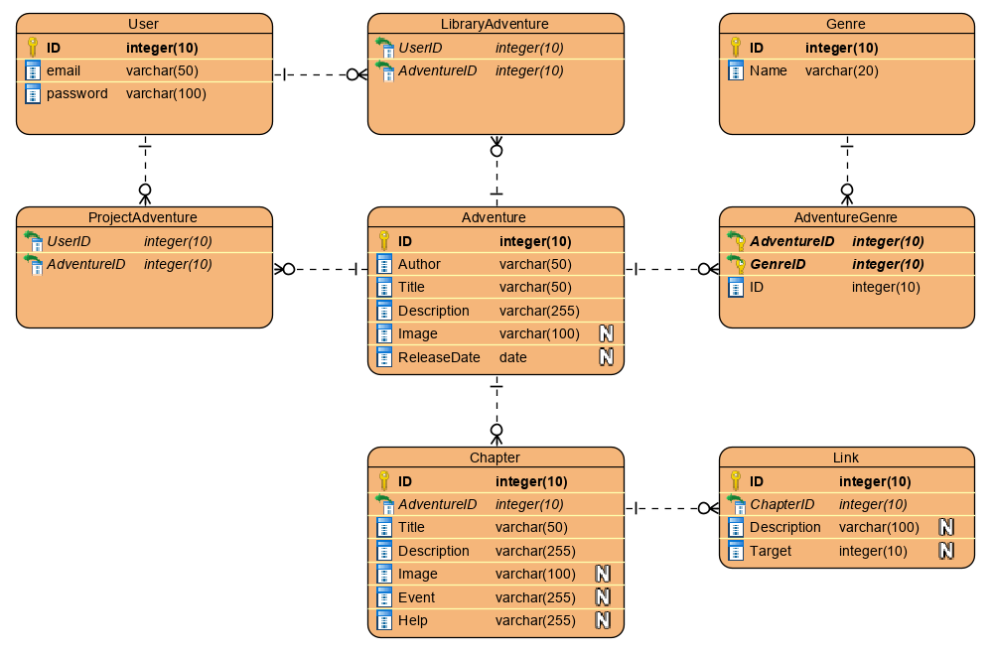

### Component Table

|  |  |  |  |
| --- | --- | --- | --- |
| Component | Metaphor | Uses | Notes |
| Index | Layout | * Navbar * ContentView | The index is a layout component which will be used on most pages in the application. |
| NavBar | NavBar |  | The NavBar will include links to the high level pages. |
| ContentView | View | * Adventures * MyLibrary * MyProjects * Account * LoginRegister * CreateEditProject * CreateEditChapter * CreateEditLink * Adventure | The content view uses routing to display the appropriate page. A single page will be displayed at any time. |
| Adventures | Page | * Filter * AdventureList * Pagination | The adventure page will allow the user to view a gallery of filtered adventures. |
| MyLibrary | Page | * Filter * AdventureList * Pagination | The adventure page will allow the user to view a gallery of filtered adventures. |
| MyProjects | Page | * Filter * AdventureList * Pagination | The adventure page will allow the user to view a gallery of filtered adventures. |
| RegisterLogin | Page / Form |  | The RegisterLogin will contain general registration and login functionality. |
| Account | Page |  | The Account page displays basic account information |
| CreateEditProject | Page | * ProjectForm * ChapterList | The CreateEditProject page will contain an editable Project Form used to create or edit a project and a list of chapters used for navigation. |
| CreateEditChapter | Page | * ChapterForm * LinkList | The CreateEditChapter page will contain an editable Chapter Form used to create or edit a project and a list of links used for navigation. |
| CreateEditLink | Page | * LinkForm | The CreateEditLink page will contain an editable Link Form used to create or edit a link. |
| ProjectForm | Form |  | The ProjectForm form will include a range of inputs. |
| ChapterForm | Form |  | The ChapterForm will include a range of inputs. |
| LinkForm | Form |  | The LinkForm will include a range of inputs. |
| Filter | Control |  | The Filter control will include a selection of drop downs to filter the list of adventures displayed in the AdventureList. |
| AdventureList | Control |  | The AdventureList will display a List of Adventures. |
| Pagination | Control |  | The Pagination Control will allow the AdventureList to be separated in to multiple pages. |
| ChapterList | Control |  | The ChapterList will display a list of Buttons used to navigate the Chapters in the current Adventure. |
| LinkList | Control |  | The LinkList will display a list of Buttons used to navigate the Links in the current Adventure. |

### Component Diagram

